

**Instituto Superior de Engenharia de Lisboa**

**Electronics, Telecommunications and Computers Engineering Department**

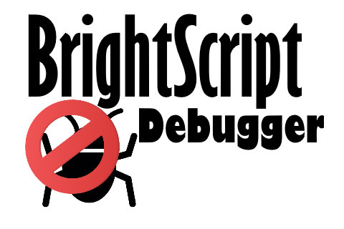

**BrightScript Debugger**

Celso de Almeida Fernandes

(Graduated in Computer Science and Computer Engineering)

Dissertation for Master's Degree in Computer Science and Computer Engineering

Advisors:

Specialist *Paulo Alexandre Leal Barros Pereira*, ISEL-ADEETC

Specialist *Pedro Alexandre Seia Cunha Ribeiro Pereira*, ISEL-ADEETC

Jury:

President: Doctor *Manuel Martins Barata*, ISEL-ADEETC

# Abstract

BrigthScript is a programming language based on JavaScript and Visual Basic, created by Roku. Roku is a company who produces and commercializes devices that are used to watch movies and television. These devices are usually connected to a TV and are commonly known as TV boxes. BrightScript is the language on which applications for their boxes are developed.

After some analysis, we could not found many development tools and the existing ones are not functional enough. Roku provides an Eclipse plugin and the boxes expose a telnet port for basic debugging. The Eclipse plugin itself only makes syntax validation and deploys the application code to the box. There are several open source plugins for the most popular text editors that perform syntax highlighting.

The goal of this project is therefore to implement an integrated tool for application development thereby simplifying the development process, that includes debugging. This tool supports syntax validation, code compilation, intellisense and graphical debug interaction.

Visual Studio is an Integrated Development Environment created by Microsoft and it is the main tool for the development of Windows applications. The tool is materialized as a Visual Studio plugin for the BrightScript language. This plugin uses the language services provided by Visual Studio SDK.

The tool could be enhanced with a box simulator that would be used to run the applications on the development machine, thereby further improving the development cycle; a goal identified as future work.

The idea for this project was a consequence of the author’s involvement on SkyStore Roku App development, for Sky UK Limited Company.

# Index

Abstract i

Index ii

1. Introduction 1

1.1. Compilers Theory 2

1.2. Code Generation tools 2

1.3. Implementation 3

2. Compilers Theory 4

2.1. Lexical Analysis 6

2.2. Parsing 7

2.3. Abstract Syntax Tree 9

3. Code Generation tools 10

3.1. GPlex 10

3.2. Gppg 11

3.3. Irony 12

3.4. JavaCC 12

3.5. SableCC 12

3.6. Conclusion 12

4. Compiler 14

4.1. Lexer 15

4.2. Parser 16

5. Debugger 17

5.1. Telnet module 18

5.2. Deploy 22

5.3. Remote 24

6. Visual Studio Plugin 26

6.1. Project Type 27

6.2. Builder/Deploy 30

6.3. Editor Extension 30

6.4. Debugger integration 32

6.5. Tool Windows 39

7. Conclusion 41

8. References 42

# Introduction

The idea for this project was a consequence of the author’s involvement on SkyStore Roku App development, for Sky UK Limited Company. This application is developed in BrigthScript and the existing tools for development ware not very functional.

The goal of this project is therefore to implement an integrated tool for BrigthScript application development thereby simplifying the development process, that includes debugging. This tool supports syntax validation, code compilation, intellisense and graphical debug interaction.

BrigthScript is a programming language based on JavaScript and Visual Basic, created by Roku. Roku is a company who produces and commercializes devices that are used to watch movies and television. These devices are usually connected to a TV and are commonly known as TV boxes. BrightScript is the language on which applications for their boxes are developed.

After some analysis, we could not found many development tools and the existing ones are not functional enough. Roku provides an Eclipse plugin and the boxes expose a telnet port for basic debugging. The Eclipse plugin only makes syntax validation and exports application code to the box. There are several open source plugins for the most popular text editors, that perform syntax highlighting.

The solution is based on a Visual Studio extension, this extension adds BrigthScript language to Visual Studio. Will be possible to create new projects, edit code, compile, deploy and debug like any other supported language. This extension exports project and item templates, language services for editor, build tasks for deploy and a debugger engine. To implement language services and compilation task was implemented a compiler for BrightScript, for debug engine was implemented a service to manage communication with the box and a compiler to process telnet output.

The project is divided into three stages. The first stage focuses the study off compilers theory. The second stage is about the investigation of existing tools for generating compilers code, how they work and their benefits. The third stage focuses the plugin implementation.

## Compilers Theory

In the first stage it was used the set of Compilers Theory videos [1], by Alex Aiken, a Professor of Computer Science in Stanford University and the book entitled Modern Compiler Implementation in Java [2]. These two sources have a very similar approach of compilers theory, suggesting a modular implementation.

BrightScript [3] is an interpreted language and therefore there is no need to implement all the customary compilation steps. In particular, the tool only has to contain the Lexer and Parser steps. If, on the other hand, we implement the simulator, then we need to implement all the compilation steps.

Regarding the two compilation steps to be implemented in the tool, the Lexer reads the code file and generates a list of tokens (also known as tokenizer) and the Parser receives the list of tokens, performs syntax validation and generates the corresponding abstract syntax tree.

## Code Generation tools

In the second stage we analyzed the use of tools to generate compiler code.

Two of the most useful abstractions used in modern compilers are context-free grammars, for parsing, and regular expressions, for lexical analysis. To make the best use of these abstractions it is helpful to have special tools, such as Yacc [4], which converts a grammar into a parsing program, and Lex [5], which converts a declarative speciﬁcation into a lexical-analysis program. According to this we analyzed the following tools:

* GPlex [6]
* Gppg [7]
* Irony [8]
* JavaCC [9]
* SableCC [10]

## Implementation

The third stage comprises the plugin implementation. The plugin is divided in three components, illustrated in Figure 1.

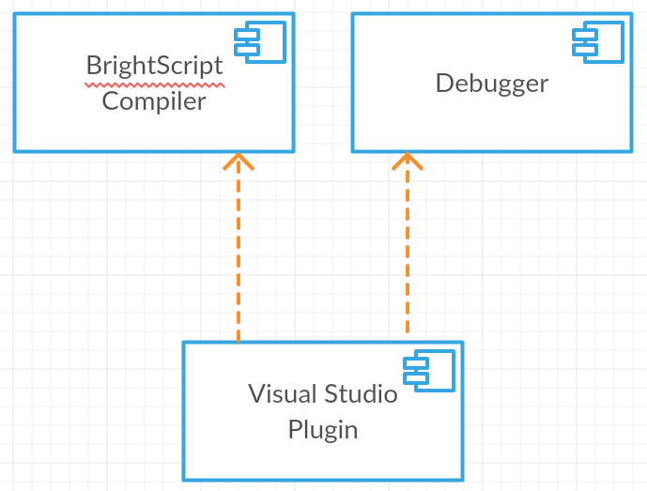

Figure 1 - Component diagram

The BrightScript Compiler is the generated code for syntax validation, therefore preventing compilation errors from occurring when deploying the code to the box.

The Debugger manages the connection with the box, using the telnet and HTTP ports. The box exposes an HTTP port to emulate remote inputs, a web page to deploy the apps and a telnet port to receive box output and send debug commands.

The Visual Studio Plugin is based on some samples, developed by Microsoft, Python Tools [11], Visual Studio Extension for Lua [12], and Visual Studio MI Debug Engine [13]. Python Tools is an extension for Visual Studio that adds Python support; Visual Studio Extension for Lua is a basic implementation for the Lua language; Visual Studio MI Debug Engine is a debugger implementation how supports the gdb Machine Interface ("MI") specification such as GDB, LLDB, and CLRDBG.

The plugin will use the compiler for syntax highlighting, syntax analysis and intellisense generation and uses the Debugger to interact with the box.

# Compilers Theory

A compiler is a computer program that processes source code, written in a specific language, and generates machine code that computers can run.

A compiler is a very complex software. To simplify its understanding and implementation, it’s modularized. Figure 2 shows compiler’s components.

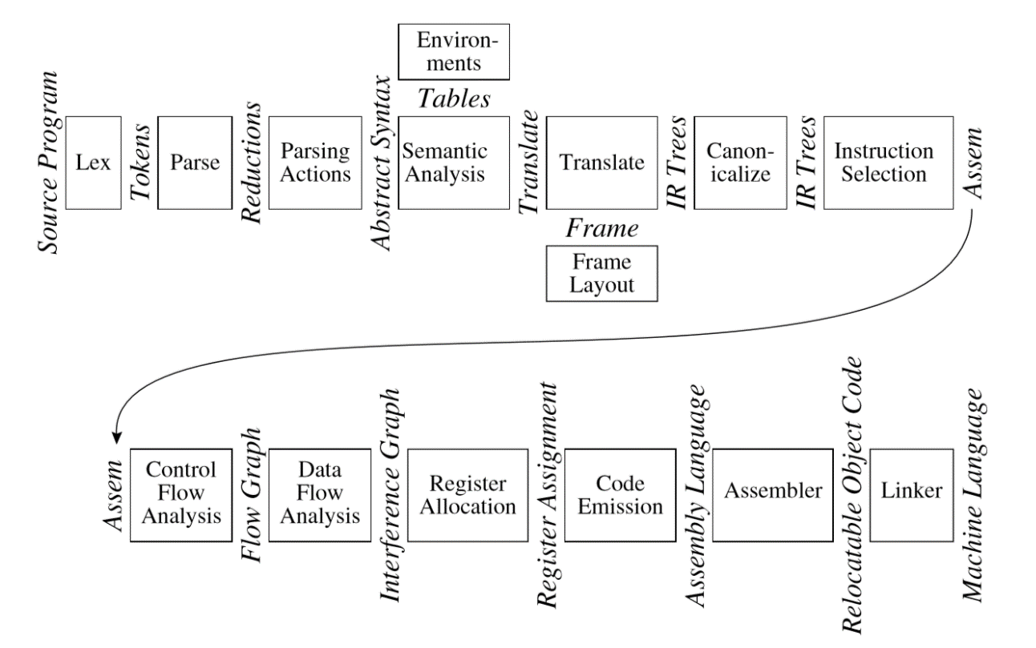

Figure 2 - Phases of a compiler, and interfaces, extracted from [2]

Each of the above models corresponds to a compiler phase, described in table 1.

|  |  |
| --- | --- |
| **Phase** | **Description** |
| Lex | Breaks the source ﬁle into individual words or tokens. |
| Parse | Analyzes the phrase structure of the program. |
| Semantic Actions | Builds a piece of abstract syntax tree corresponding to each phrase. |
| Semantic Analysis | Determines what each phrase means, relates uses of variables to their deﬁnitions, checks types of expressions, requests translation of each phrase. |
| Frame Layout | Places variables, function-parameters, etc. into activation records (stack frames) in a machine-dependent way. |
| Translate | Produces intermediate representation trees (IR trees), a notation that is not tied to any particular source language or target-machine architecture. |
| Canonicalize | Hoists side effects out of expressions, and cleans up conditional branches, for the convenience of the next phases. |
| Instruction Selection | Groups the IR-tree nodes into clumps that correspond to the actions of target-machine instructions. |
| Control Flow Analysis | Analyzes the sequence of instructions into a control ﬂow graph that shows all the possible ﬂows of control the program might follow when it executes. |
| Dataﬂow Analysis | Gathers information about the ﬂow of information through variables of the program; for example, liveliness analysis calculates the places where each program variable holds a still-needed value (is live). |
| Register Allocation | Chooses a register to hold each of the variables and temporary values used by the program; variables not live at the same time can share the same register. |
| Code Emission | Replaces the temporary names in each machine instruction with machine registers. |

Table 1 - Compiler phases, extracted from [2]

## Lexical Analysis

The lexical analyzer takes a stream of characters and generates a stream of tokens. It discards white spaces and comments between the tokens. The parser doesn’t have to handle possible white space and comments at every possible point.

A lexical token is a sequence of characters that is a grammar unit of a programming language. A programming language classiﬁes lexical tokens into a ﬁnite set of token types.

A language is a set of strings and a string is a ﬁnite sequence of symbols. The symbols themselves are taken from a ﬁnite alphabet.

To specify the language alphabet, we use regular expressions. Each regular expression represents a set of strings.

Regular expressions can specify lexical tokens, but we need an algorithm that can be implemented as a computer program.

For this we use ﬁnite automata. A ﬁnite automaton has a ﬁnite set of states, edges lead from one state to another, and each edge is labeled with a symbol. One state is the start state, and certain of the states are distinguished as ﬁnal states. Figure 3 shows a finite automaton sample.

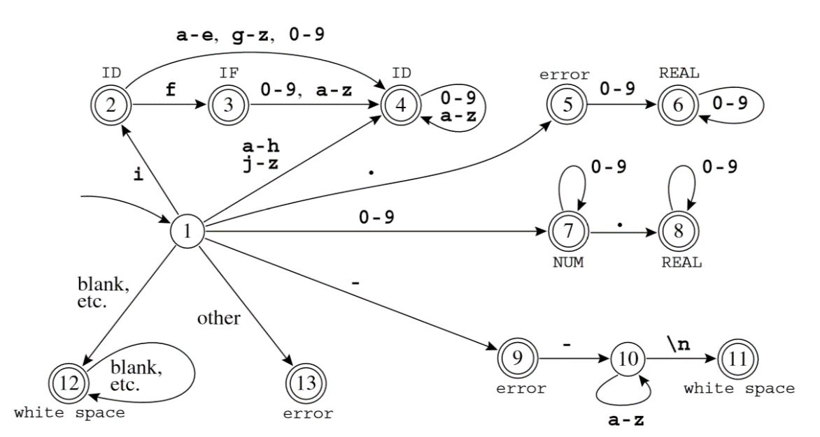

Figure 3 - Combined ﬁnite automaton, extracted from [2]

Lexical analyzer needs to find the longest matches, using the finite automata we just need to remember the last finite state. Each match corresponds to a token, after find a token the automaton reinitializes.

As result of lexical analysis phase, the lexical analyzer generates a list of tokens, to be consumed by the Parser.

## Parsing

The parser makes the syntax analysis, validates the order of words and the way they are put together to form phrases, clauses, or sentences.

For syntax analysis we use context-free grammars. Grammars deﬁne syntactic structure declaratively. We need something more powerful than ﬁnite automata to parse languages described by grammars.

A language is a set of strings, each string is a ﬁnite sequence of symbols taken from a ﬁnite alphabet. For parsing, the strings are source programs, the symbols are lexical tokens, and the alphabet is the set of token-types returned by the lexical analyzer. A context-free grammar describes a language. A grammar has a set of productions of the form

symbol → symbol symbol ···symbol

where there are zero or more symbols on the right-hand side. Each symbol could be terminal, meaning that it is a token from the alphabet of strings in the language, or non-terminal, meaning that it appears on the left-hand side of some production. Tokens cannot appear on the left-hand side of a production. One of the non-terminals is the start symbol of the grammar.

To show that this sentence is in the language of the grammar, we can perform a derivation: Start with the start symbol, then repeatedly replace any nonterminal by one of its right-hand sides. There are many different derivations of the same sentence. A leftmost derivation is one in which the leftmost nonterminal symbol is always the one expanded, in a rightmost derivation, the rightmost nonterminal is always the next to be expanded. Figure 4 shows a state table sample for a grammar.

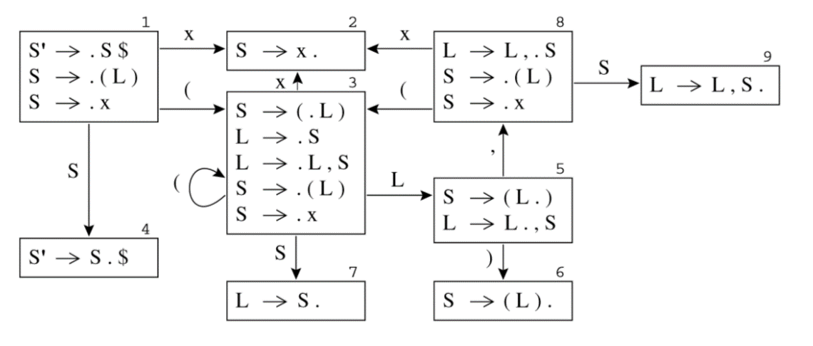

Figure 4 - LR(0) states for Grammar, extracted from [2]

A compiler does more than recognize if a sentence belongs to the language of a grammar, it performs semantic actions. In a parser implementation, semantic actions are fragments of code attached to grammar productions that generates the syntax tree.

The Abstract Syntax Tree (AST) is the output of syntax analysis phase.

## Abstract Syntax Tree

Abstract syntax trees are data structures used in compilers, they can represent the structure of program code. An AST is the result of the syntax analysis phase of a compiler. It is an intermediate representation of the program that can be used in several stages that the compiler, and has a strong impact on the final output of the compiler. Figure 5 shows a syntax tree sample.

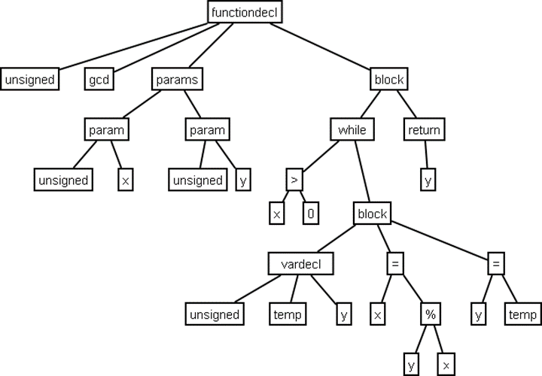

Figure 5 - Abstract Syntax Tree Sample, extracted from [2]

# Code Generation tools

Code generation tools are used to perform simple tasks that can be automatic. Deterministic Finite Automaton (DFA) construction is a mechanical task, so it makes sense to have an automatic lexical-analyzer generator to translate regular expressions into a DFA. The task of constructing a parser can be automated too.

## GPlex

Gardens Point LEX (GPlex) generates scanners based on ﬁnite state automata. The generated automata have the number of states minimized by default, and have a large number of options for table compression. The default compression scheme is chosen depending on the input alphabet cardinality, and almost always gives a reasonable result. However, a large number of options are available for the user to tune the behavior if necessary. The tool implements many of the FLEX extensions, including such things as start state stacks. The generated scanners are designed to interface cleanly with bottom-up parsers generated by Gardens Point Parser Generator (gppg).

GPlex is a scanner generator which accepts a “LEX-like” speciﬁcation, and produces a C# output ﬁle. The tool does not attempt to implement the whole of the POSIX speciﬁcation for LEX, however the program moves beyond LEX in some areas, such as support for Unicode.

The scanners produce by GPlex are thread safe, in that all scanner state is carried with in the scanner instance. The variables that are global in traditional LEX are instance variables of the scanner object. Most are accessed through properties which expose only a getter.

There are two main ways in which GPlex is used. In the most common case the scanner implements or extends certain types that are deﬁned by the parser on whose behalf it works. Scanners may also be produced that are independent of any parser, and perform pattern matching on character streams. In this “stand-alone” case the GPlex tool inserts the required super type deﬁnitions into the scanner source ﬁle.

The code of the scanner derives from three sources. There is invariant code which deﬁnes the class structure of the scanner, the machinery of the pattern recognition engine, and the decoding and buffering of the input stream. These parts are deﬁned in a “frame” ﬁle and a “buffers” ﬁle each of which is an embedded resource of the GPlex executable. The tables which deﬁne the ﬁnite state machine that performs pattern recognition, and the semantic actions that are invoked when each pattern is recognized are interleaved with the code of the frame ﬁle. These tables are created by GPlex from the user-speciﬁed “*.lex” input ﬁle. Finally, user-speciﬁed code may be embedded in the input ﬁle. All such code is inserted in the main scanner class deﬁnition. Since the generated scanner class is declared partial it is also possible for the user to specify code for the scanner class in a C# ﬁle separate from the LEX speciﬁcation.

## Gppg

Gardens Point Parser Generator (Gppg) is a parser generator that produces parsers written in the C# language. Gppg generates bottom-up parsers. The generated parsers recognize languages that are LALR(1), with the traditional Yacc disambiguation’s. There are a number of extensions of the traditional input language that are necessary for correctness of the generated C# output ﬁles.

A particular feature of the tool is the optional generation of an html report ﬁle that allows easy navigation of the ﬁnite state automaton that recognizes the viable preﬁxes of the speciﬁed language. The report shows the production items, look ahead symbols and actions for each state of the automaton. It also optionally shows an example of a shortest input, and shortest FSA-path reaching each state.

Gppg parser generator accepts a “Yacc-like” speciﬁcation, and produces a C# output ﬁle. Both the parser generator and the runtime components are implemented entirely in C#.

## Irony

Irony is a development kit for implementing languages on .NET platform. Unlike most existing Yacc/Lex-style solutions, Irony does not employ any scanner or parser code generation from grammar specifications written in a specialized meta-language. In Irony, the target language grammar is coded directly in C# using operator overloading to express grammar constructs. Irony's scanner and parser modules use the grammar encoded as C# class to control the parsing process.

## JavaCC

Java Compiler Compiler (JavaCC) is the most popular parser generator for use with Java applications. A parser generator is a tool that reads a grammar specification and converts it to a Java program that can recognize matches to the grammar. In addition to the parser generator itself, JavaCC provides other standard capabilities related to parser generation such as tree building and parsing actions.

## SableCC

SableCC is a parser generator, which generates fully featured object-oriented frameworks for building compilers, interpreters and other text parsers. In particular, generated frameworks include intuitive strictly-typed abstract syntax trees and tree walkers. SableCC also keeps a clean separation between machine-generated code and user-written code which leads to a shorter development cycle.

## Conclusion

After analyzing the presented tools and the Visual Studio SDK, we get the following conclusions:

* The Visual Studio plugins only use .Net code, the Parser and the Lexer should be in C# or Visual Studio code.
* JavaCC only generates Java Lexer’s and Java Parser’s.
* SableCC can’t generate pure .Net code, only Java in C# style.
* Irony doesn’t use Yacc or Lex common definitions, the definition can’t be used in other implementations.
* GPlex generates a C# Lexer based on Lex definition.
* Gppg generates a C# Parser based on Yacc definition.

The GPlex and Gppg matches all requirements and are designed to work together. According to this we chose GPlex and Gppg.

# Compiler

The Compiler is composed of two components: The Lexer (also called Scanner) and the Lexer. The purpose of the compiler is to process code files, generating compilation errors, if they exist, and build the abstract syntax tree for intellisense functionality. Figure 6 shows components diagram of the compiler.

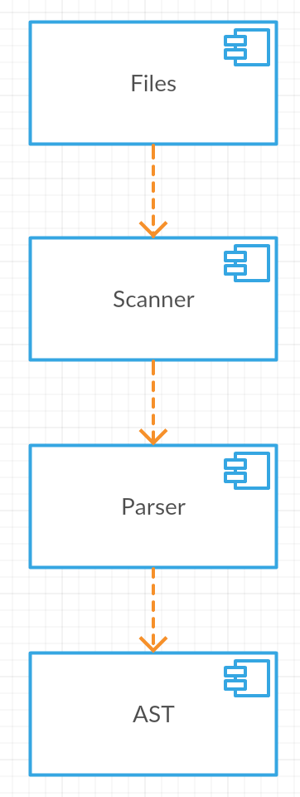

Figure 6 - Compiler Components

## Lexer

The lexical analyzer makes lexical validation and generates tokens for the Parser. This validation consists in verifying if the code is according to the lexical definition for this language.

The lexical analyzer is a state machine that tries to find the longest tokens. It reads character by character changing to the possible states. When it founds a token, removes the string form the source and generates the token.

The Lexer is generated by GPlex, who generates a C# file with the state machine implementation. GPlex reads the definition file (*.lex) with the regular expressions and generates the Finite State Automata (FSA) tables. Figure 7 shows a FSA sample.

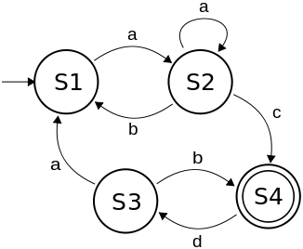

Figure 7 - FSA - Finite State Automata, extracted from [2]

The Visual Studio SDK uses the Lexer for two different purposes, the first is for syntax highlighting and the second is to generate tokens for Parser. The syntax highlighting needs less tokens then the parser, according to this we generate two Lexers one for each purpose.

## Parser

The Parser analyzes the grammatical structure of the language. It validates the sentences, if the tokens are in the right order. This analysis allows the Parser to generate the abstract syntax tree (AST), which is its output.

The grammatical structure is defined by a set of rules, named context-free grammars, defined in the Yacc file. These rules define the tokens’ order.

The Parser is generated by Gppg, which generates a C# file with the implementation of the Parser. The generated Parser implements the Shift-Reduce algorithm and generates the AST by calling actions on reduce. Figure 8 shows a shift-reduce sample table.

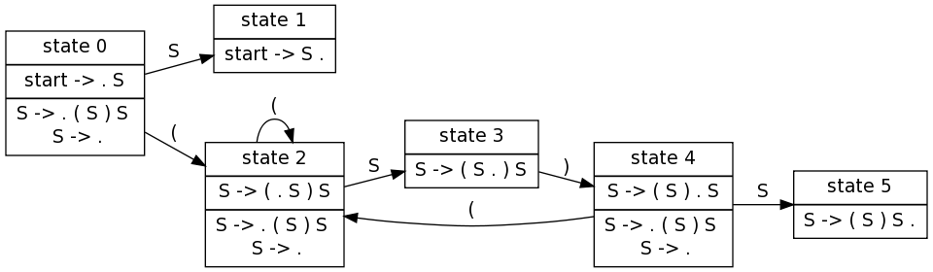

Figure 8 - Shift reduce table, extracted from [2]

Gppg allows to define actions written in C#, this actions returns the AST nodes and builds the AST using these nodes.

# Debugger

The Debugger is the tool that performs the deployment of the app to the box, and manages the interface between the telnet port and Visual Studio.

The debugger has three main components, namely: Telnet, Deploy and Remote, as depicted in figure 9.

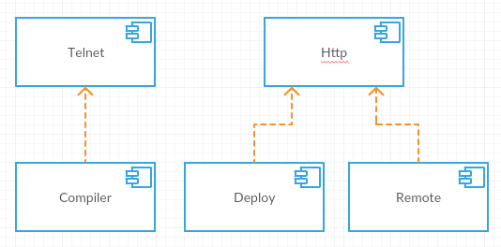

Figure 9 - Debuger diagram

The Telnet module uses a Compiler to parse the telnet output and generates debug context. The Deploy module generates the deployment package and uploads it to the box, using HTTP. The Remote module uses HTTP to emulate remote input.

The debugger will be integrated in Visual Studio Plugin, but should be independent without the Visual Studio SDK dependencies, for reuse purposes. To implement and test the functionalities we created. Figure 10 shows the debugger application.

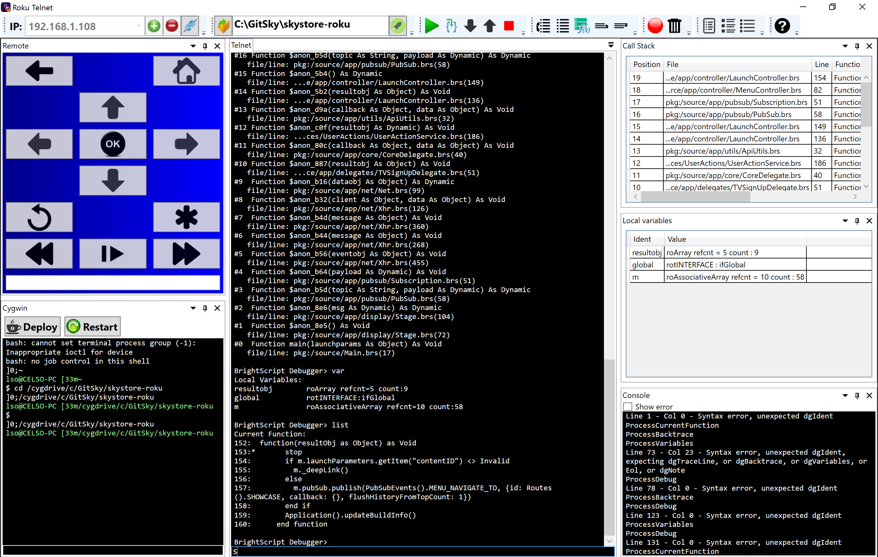

Figure 10 - Debugger Application

The app is implemented according to the debugger diagram, depicted in Figure 10.

## Telnet module

The Telnet module has two functionalities: to show the box output, and send it debug commands.

The box output is done using print or stop keywords in the source code files. The print keyword writes to the output, similarly to the printf function from C’s standard library. The stop keyword makes puts the box in debug mode. In this mode, the box accepts debug commands, which are described in table 2.

|  |  |
| --- | --- |
| **Command** | **Description** |
| **bsc** | Print current BrightScript Component instances |
| **bscs** | Print a summary of BrightScript component instance counts by component type. |
| **brkd** | Toggle whether BrightScript should break into the debugger after non-fatal diagnostic messages. |
| **bt** | Print backtrace of call function context frames |
| **classes** | Print Brightscript Component classes |
| **cont**or**c** | Continue Script Execution |
| **down** or **d** | Move down the function context chain one |
| **exit** | Exit shell |
| **gc** | Run garbage collector |
| **help** | Print the list of debugger commands |
| **last** | Print the last line that executed |
| **list** | List current function |
| **next** | Print the next line to execute |
| **print, p,**or**?** | Print a variable or expression |
| **step, s, or t** | Step one program statement |
| **over** | Step over function |
| **out** | Step out of a function |
| **up** or **u** | Move up the function context chain one |
| **var** | Print local variables and their types/values |
| Any Brightscript statement | Execute an arbitrary Brightscript statement |

Table 2 - Debug commands, extracted from [3]

Using the debugger, it’s possible to get the current variables’ value and get information about the call stack.

The implementation of the component uses a socket to connect to the telnet port and a compiler that compiles the debugger output, to generate the debugger context. Figure 11 shows the Telnet component diagram.

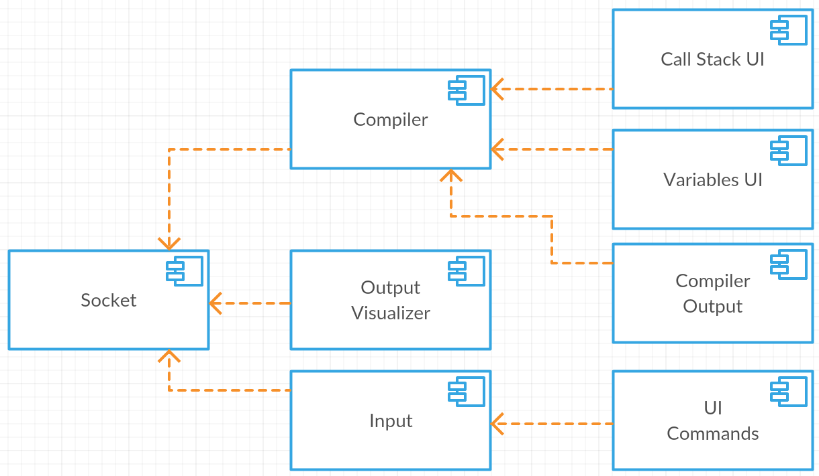

Figure 11 - Telnet component diagram

The Socket component represents the communication layer and is implemented using a socket that connects to telnet port of the box; the Compiler component uses the output of the socket to Parse this output and generates call stack and variables information; Call Stack UI and Variables UI shows the corresponding information to the user; Compiler Output shows debugging info of the Compiler; Output visualizer shows all the output of the Telnet port; Input allows the user to execute code or debug commands on the box, sending them to them through the Socket Component; UI Commands is a tool bar that exposes the debug commands as icons.

Figure 12 shows the compiler’s output windows.

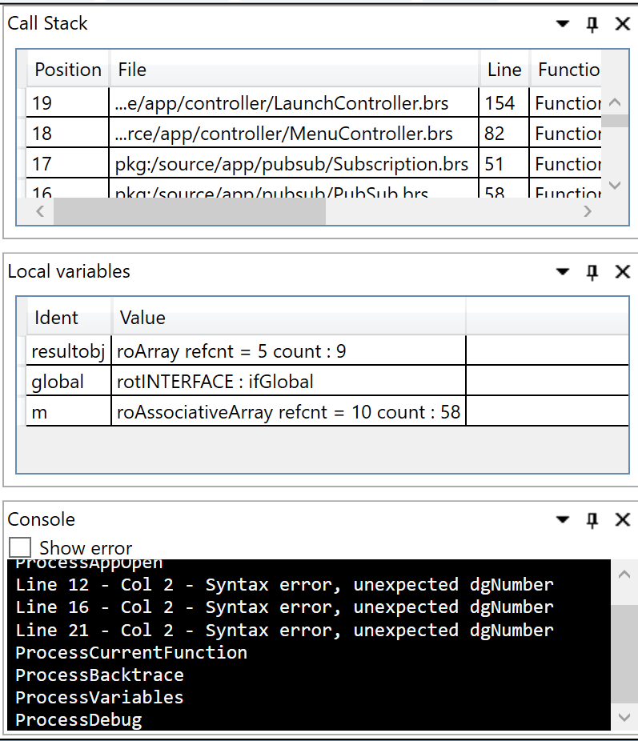

Figure 12 - Compiler output windows

Figure 13 show telnet output visualizer.

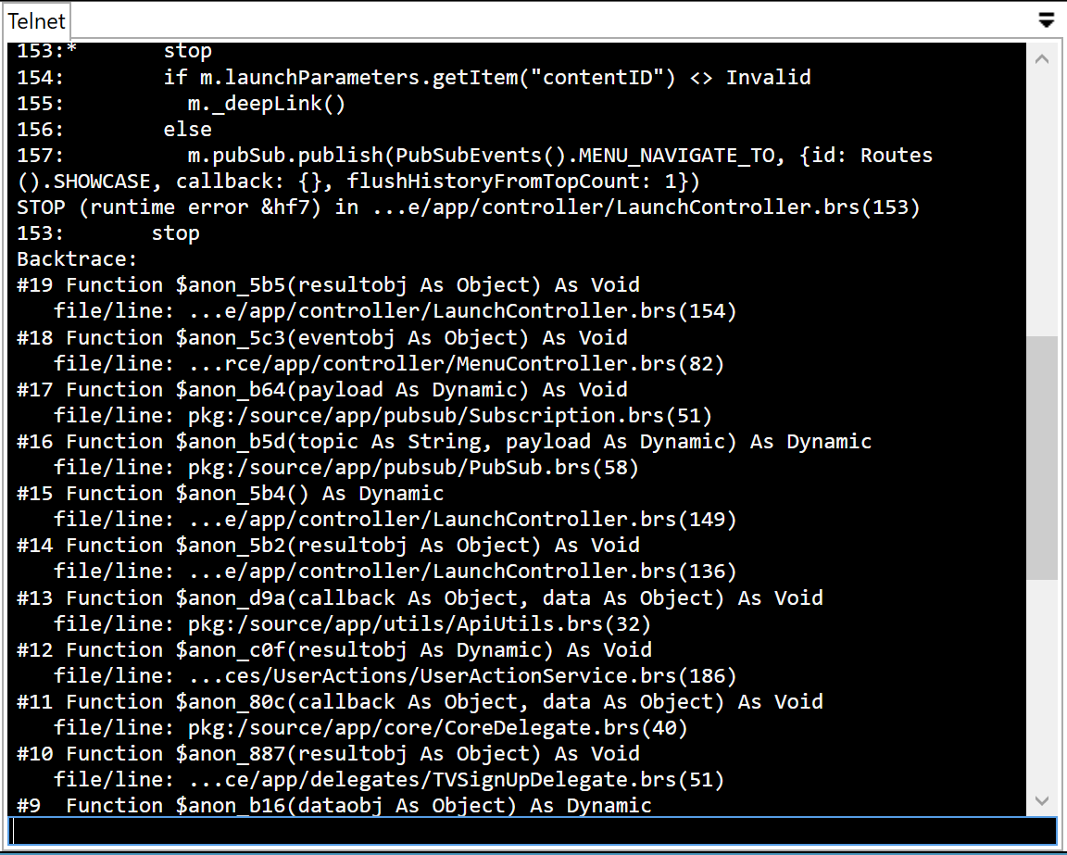

Figure 13 - Output visualizer

Figure 14 shows app tool bar.



Figure 14 - UI Commands

## Deploy

The deploy process consists in generating a zip file bearing the source files and uploading it to the box, using the HTTP port. The figure 15 shows the deploy steps.

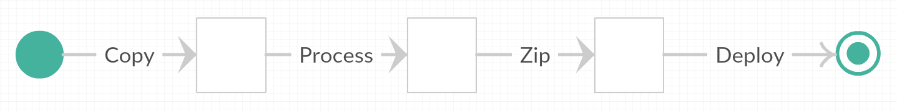

Figure 15 - Deploy process

To deploy the application, we copy all the source files to the output folder; process this files; generate a zip archive width all files; and upload it to the box.

The process step is introduced to allow the developer to pass build parameters to the deployed application. This is done by replacing specific blocks of code or removing source files from output folder. This allows to filter the folders to deploy; to remove blocks of code that was used for debug proposes; to inject code that is used to pass parameters.

The process uses several configurations. In order to support it, a page for managing the deploy configurations was created. Figure 16 shows the configuration page.

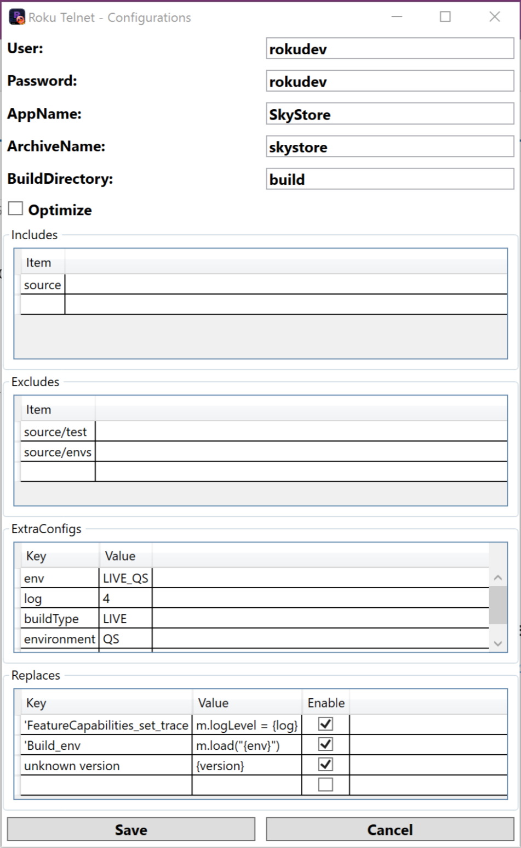

Figure 16 - Configurations Window

The upload step requires the developer’s credentials (i.e. username and password) to be used on accesses to HTTP port of the box. These credentials are specified at the top of the configurations window; The optimize configuration removes comments, empty lines and extra spaces from code files; The section named includes contains the list of sub folders to include in the zip file that will be uploaded; The exclude section contains the list of sub folders to exclude from deploy; The extra configs and the Replaces section allows the developer to pass custom parameters to the deployed application, this can be done just by define the replace key and the replace value. The replace key is the block of code that will be replaced and the value is the block of code that will replace it. The value of Replaces can use the extra configs, if the value of replace has a key of extra config between curly braces this block will be replaced for extra config value before the replace ware applied to source files.

The Box site uses digest authentication and multi-part form data to interact with the Box utils, .Net doesn’t implement this algorithms, we need to provide an implementation. On Deploy step we use these algorithms to upload the zip file using a POST to Box site.

## Remote

The Remote component is a remote emulator that allows the developer to control the box using the PC. The component has common keys of Roku’s remotes and has an additional text box that allows the developer to send text to box.

The implementation of this component uses the Roku External Control Service Commands over HTTP, that allows to send remote instructions.

Figure 17 shows remote window.

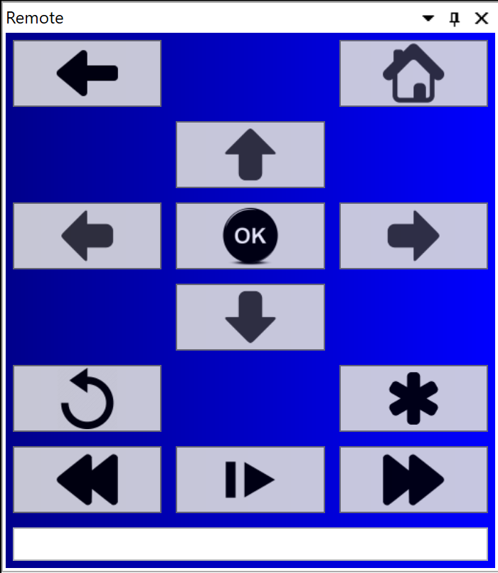

Figure 17 – Remote

Using this component the developer can debug and control the box using the same application.

# Visual Studio Plugin

Visual Studio behavior can be extended in several ways. We are using “MefComponent”, “VsPackage”, “ProjectTemplate” and “ItemTemplate” extension points.

The “MefComponent” uses Mef [13], MEF is a library for creating lightweight, extensible applications. It allows Visual Studio to discover and use extensions with no configuration required.

The “VsPackages” [15] are software modules that extend the Visual Studio integrated development environment (IDE) by providing UI elements, services, projects, editors, and designers

The “ProjectTemplates” [16] are templates to create new project files, this templates can be selected when the developer creates a new project. The project file is a MSBuild that describes the project. The project description has all files of the project and the project configurations.

The “ItemTemplates” [17] are templates to create new items for the project, can be used when the developer creates a new file in the project.

The Visual Studio Plugin implementation is separated on five different components, the project type, the builder/deploy, the editor extensions, the debugger integration and tool windows.

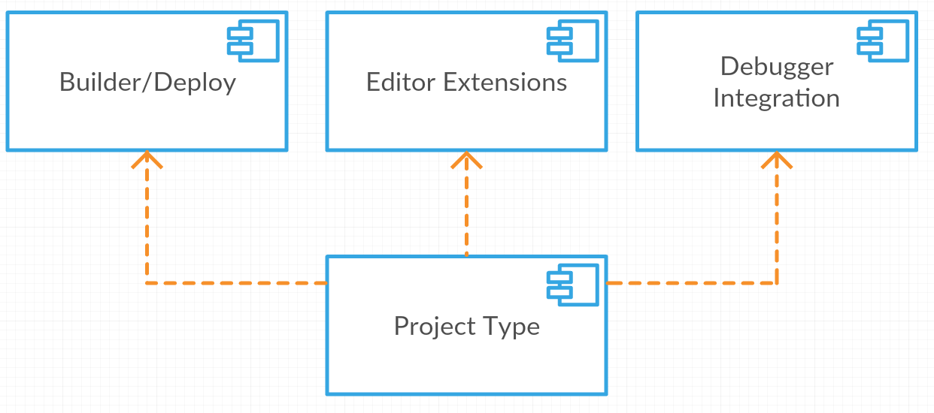

Figure 18 - Visual Studio Plugin diagram

Project Type component is the main component and generates the plugin installation. This component is also responsible to expose the project file template and the code files template, these templates will be used by the Visual Studio to create new projects and/or new code files.

Builder/Deploy Component implements the MSBuild tasks to use when the developer builds or runs the project.

Editor Extensions Component extends the Visual Studio editor adding syntax highlighting, error validation, and intellisense.

Debugger integration implements the Debugger Engine. This component receives debugger commands and send debug events to Visual Studio.

Tool windows exposes the Debugger Remote control and screen shot window.

## Project Type

The project type provides the templates to create the BrightScript project and for create the code files.

In project type implementation we used VSProjectSystem [14], this base implementation has the most common code to create project types.

The project template defines the base project file and the default items to be created on project creation. The project file is MSBuild project [19] file, written in XML. The MSBuild project defines the files to appear in project solution, the build action for each file, project configurations, and the workflow for build and deploy the app. The workflow uses the tasks described on Builder/Deploy section.

The project template needs to be registered on plugin to appears on new project dialog. Figure 19 shows the project dialog window width new project type.

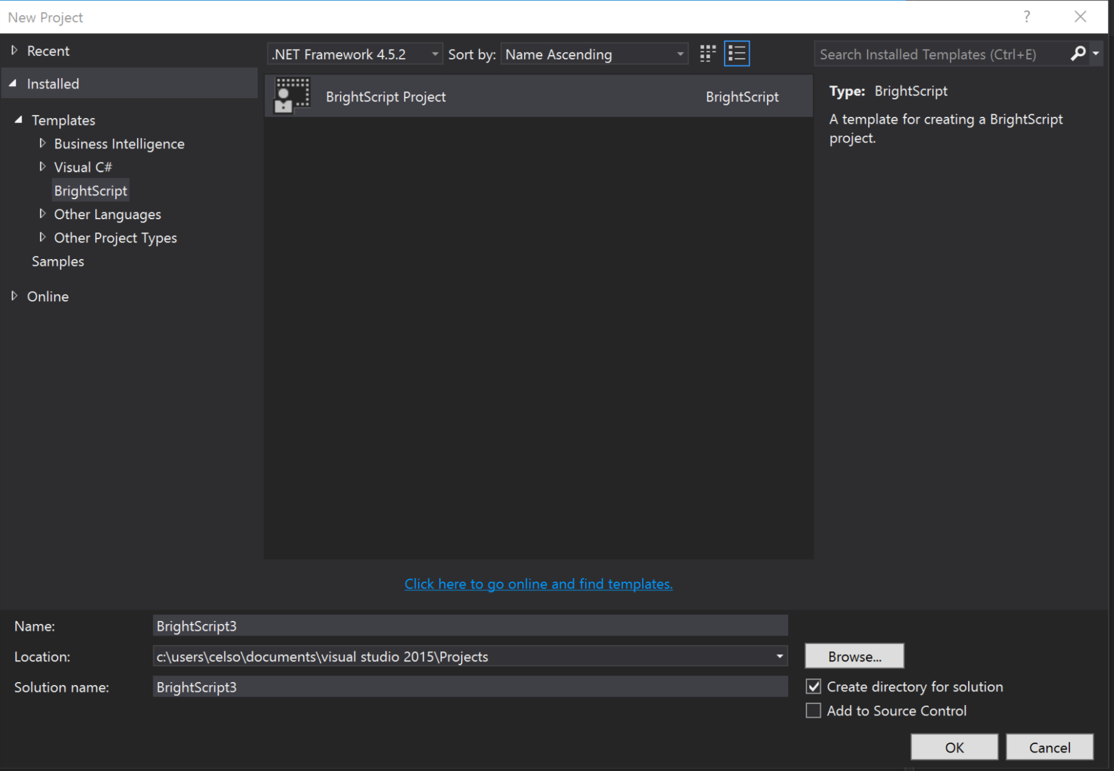

Figure 19 - Visual Studio project dialog

The project template contains the set of base code files that are added to the solution upon project creation. Figure 20 shows project structure, after being created.

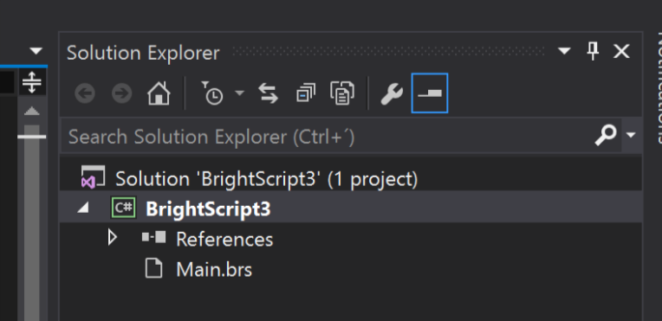

Figure 20 - Project created

Using VSProjectSystem [14], we need to define all item templates and register them, for the code files to appear in the solution explorer.

The item templates are the base set of code files, that appears on new item dialog and contains the base code structure. Figure 21 shows the new item dialog.

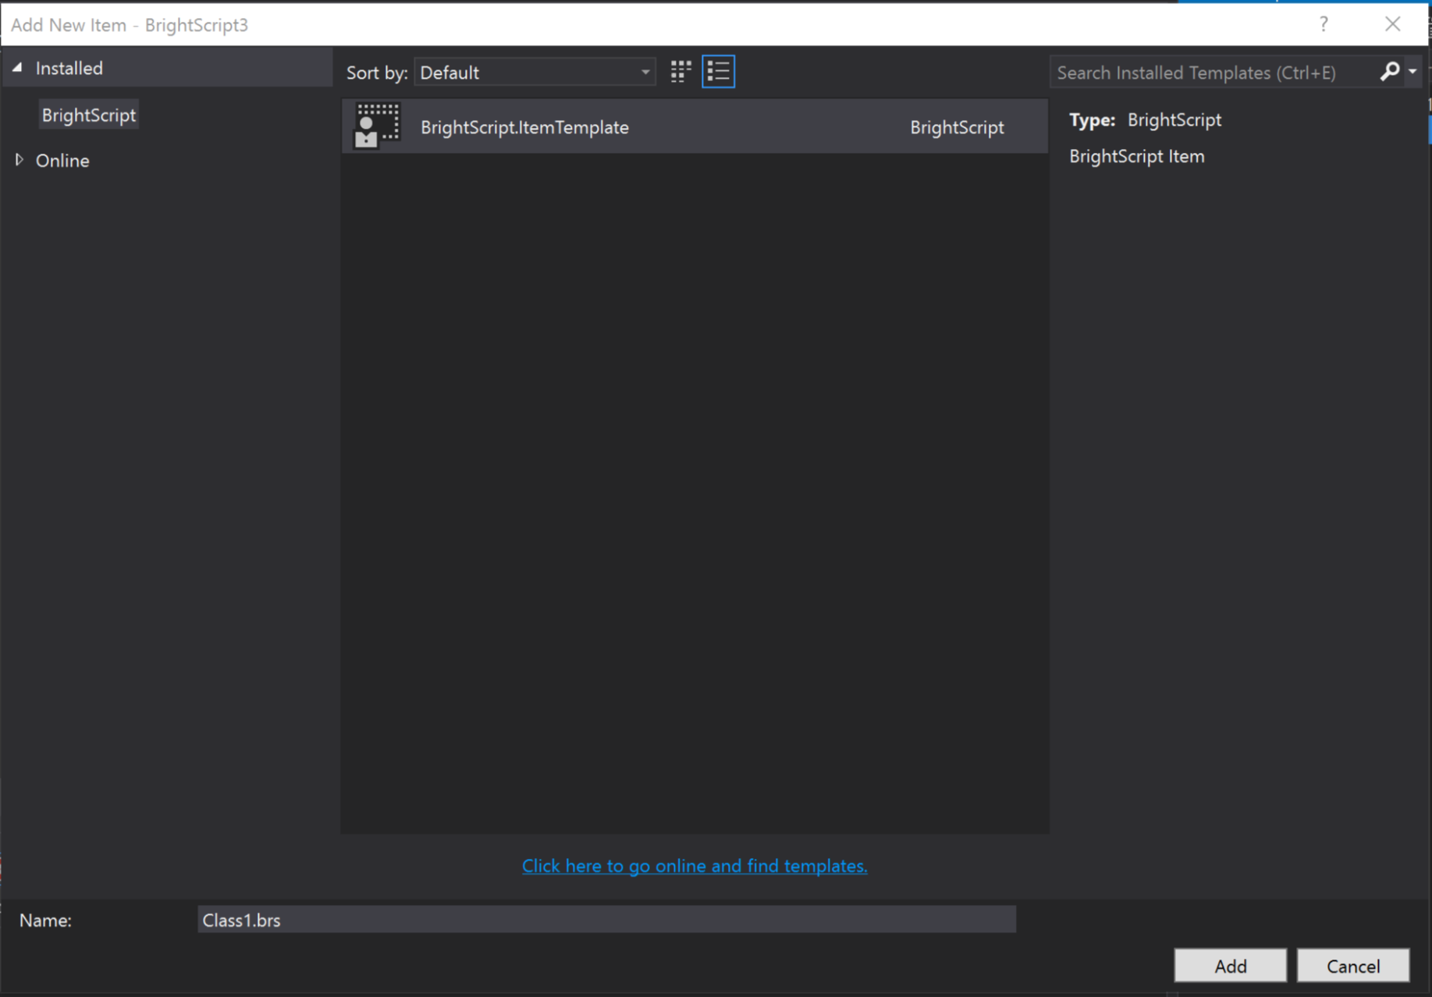

Figure 21 - New item dialog

Figure 22 shows create file, after being created.

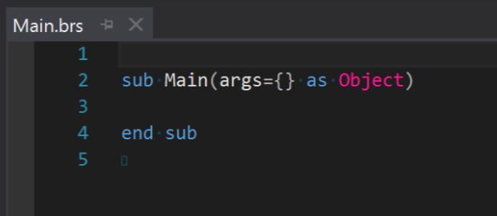

Figure 22 - Base code file

## Builder/Deploy

The builder/deploy component implement’s the tasks to be used on build process. The behavior is the same of described in Debugger section, but there’s an additional CompileTask step, this task uses the compiler to validate the code before deploy.

Table 3 describes all the created tasks:

|  |  |
| --- | --- |
| **Task** | **Description** |
| CompileTask | Uses the Compiler to validate the code before deploy. |
| CopyToOutputTask | Copy files to output path |
| GitVersionTask | Generates a output parameter width last tag from Git repository |
| ManifestTask | Edits manifest file replacing app name and version |
| ReplacesTask | Replace specific file contents. Used to pass parameters for app |
| OptimizeTask | Remove following code:   * Empty lines * Comments * Duplicated spaces * Code between ‘%--‘ and ‘--%’ tags |
| ArchiveTask | Generates the zip file to be deployed |
| DeployTask | Uploads the zip file to the box |

Table 3 – MSBuild tasks

## Editor Extension

The editor extensions provide syntax highlighting, error validation and intellisense.

The syntax highlighting is supported by the Lexer, that generates tokens for syntax highlighting. To expose that functionality, we need to create and export a class that implements the “*ITaggerProvider”* interface. Figure 23 depicts the editor window displaying syntax highlighting for the BrightScript language.

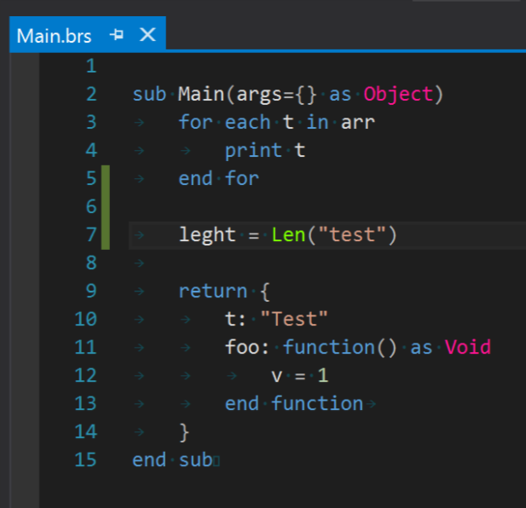

Figure 23 - Syntax highlighting

The compiler errors are supported by the Parser which compiles the source code and generates the existing compiling errors. Compiling errors are displayed on the editor as underlining mark and are listed on the errors window, as depicted in figure 24 and figure 25.

This functionality is supported by exporting a “ITaggerProvider” implementation of type “ErrorTag”. The Error tagger provides the existing compilation errors.

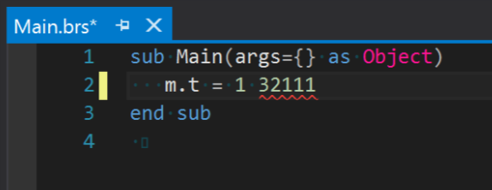

Figure 24 - Editor error

The error window uses “ErrorListProvider” class to show the generated errors. Figure 25 shows an example of an error on error window.

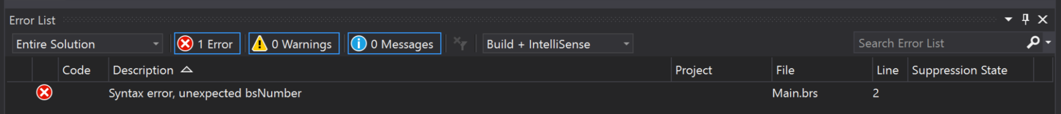

Figure 25 - Error window

The intellisense component uses the Parser to generate the AST and exports an implementation of “ICompletionSourceProvider” interface to generate the list of suggestions. We need to implement “IVsTextViewCreationListener” to register the command handler to show the list. Figure 26 shows the intellisense popup.

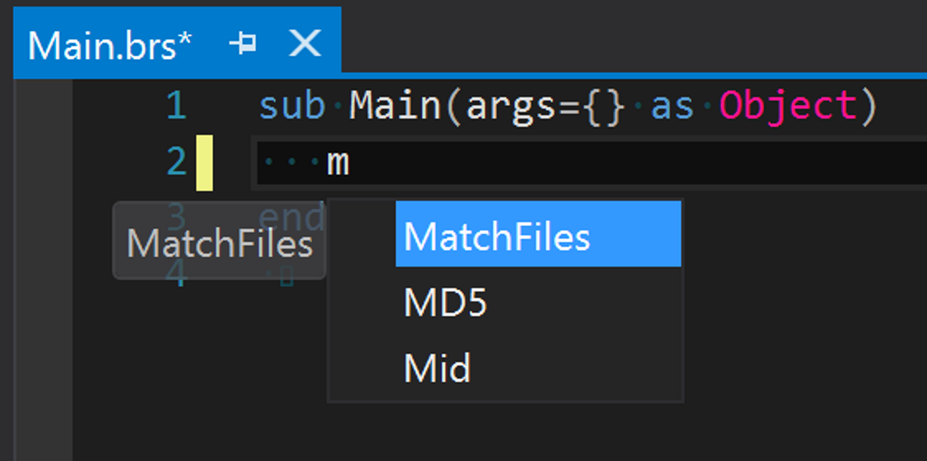

Figure 26 – intellisense

## Debugger integration

The debugger was based on Visual Studio MI Debug Engine [13] and use the implementation developed for Debugger App, that manage the connection with the box and shows debug output.

To implement a debugger, we need to perform three tasks. Register Debug Engine, create a debug launcher, and Implement Debug Engine.

Debugger engine needs to be registered in Windows register to be used, this is implemented using a registration attribute, used on Visual Studio package.

Visual Studio needs a Launcher implementation to specify witch Debug Engine to create.

The Debug Engine implementation uses the following components to communicate width Visual Studio: “AD7Engine”, “AD7Thread”, “AD7StackFrame”, “AD7DocumentContext”, “AD7Events”.

“AD7Engine” exposes methods for Launch, Resume, Suspend, Step, and Terminate debugger, manages the main interactions width Visual Studio. “AD7Thread” represents the current thread on debugging app, exposes thread id, thread name, and current stack list. “AD7StackFrame” represents a frame of stack list. “AD7DocumentContext” represents the document and line of specific stack frame. “AD7Events” implements the debugger events, to be send to Visual Studio. Using these events, we can pass current state of debugger to Visual Studio.

This component uses the following components to implement Debugger Engine logic. The implementation is based on the following components: “DebuggedProcess”, “EngineCallback”, “RokuController”, “CommandFactory”, “ThreadCache”, “WorkerThread”, “TcpTransport”, “Parser” “VariableInformation”.

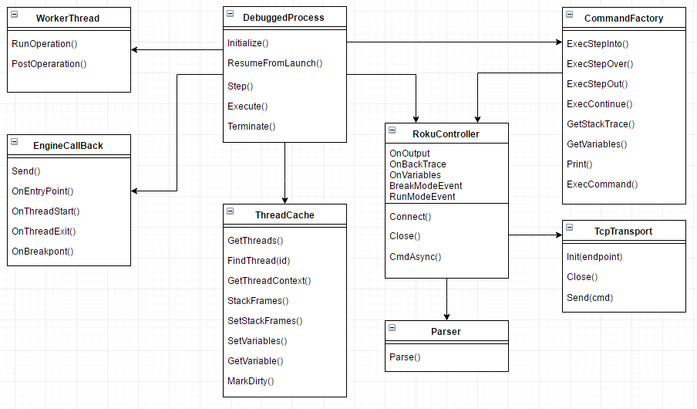

Figure 27 - Debug Engine Class Diagram

The “DebuggedProcess” manages all debug engine state, receives commands from “AD7Engine” and events from “RokuController”, uses “EngineCallback” to send events to Visual Studio.

“EngineCallback” is the component that sends “AD7Events” to Visual Studio, this events needs to be send always from the same thread, to solve this requirement, this component has a private thread to send all events.

“RokuController” manages the connection to the box, uses “TcpTransport” to communicate with the box and “Parser” to parse the “TcpTransport” output. This component manages the command response state, sending the commands and validate box responses.

The Debug Parser detects output patterns to and generates Backtrace and Variables.

The “CommandFactory” component send specific commands to “RokuController”, is responsible for generate commands to be send.

The “WorkerThread” is responsible to run background tasks to avoid UI freezing.

The “ThreadCache” component holds thread state to avoid multiple calls to the box.

The “VariableInformation” represents a variable on the box and is used to show on Local Variables window or on Watch window.

Figure 27 shows Visual Studio in debug mode.

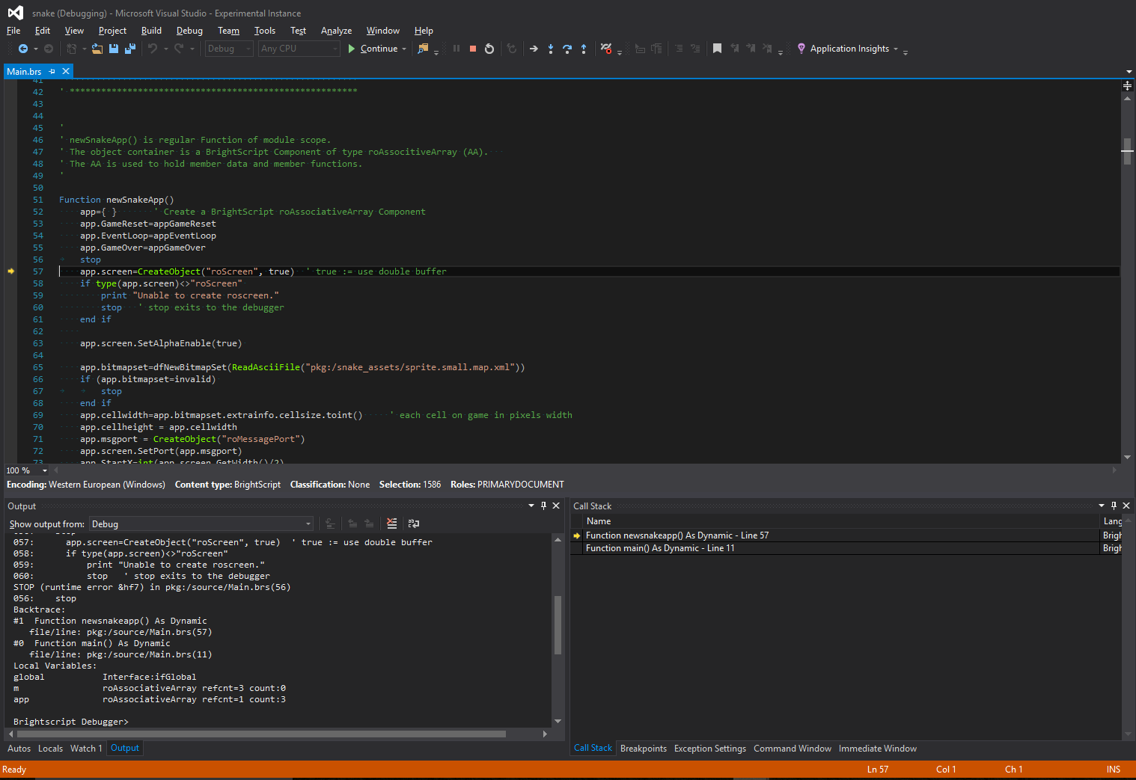

Figure 28 - Debugging BrightScript

The “DebuggedProcess” sends the box output to Visual Studio using “AD7OutputDebugStringEvent”, the output is shown on Output window like shown on figure 29.

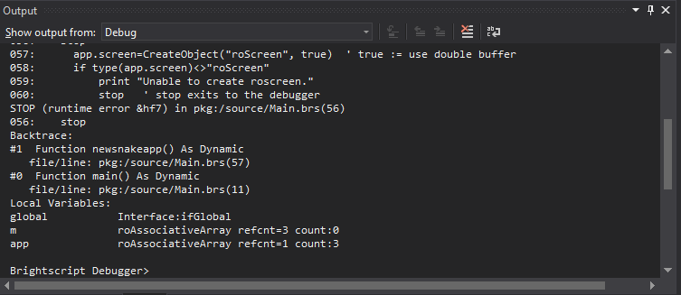

Figure 29 - Output Window

When the Box enter on break mode “DebuggedProcess” sends a “AD7BreakpointEvent” to Visual Studio with the list of “AD7StackFrame” each stack frame has “AD7DocumentContext” that connects the stack frame to a document. Figure 30 shows the Call Stack window and Figure 31.

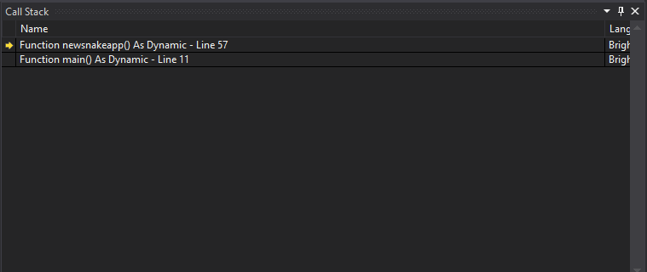

Figure 30 - Call Stack Window

The Call Stack Window allows to navigate on call stack. The editor window shows the stack position like shown on figure 31.

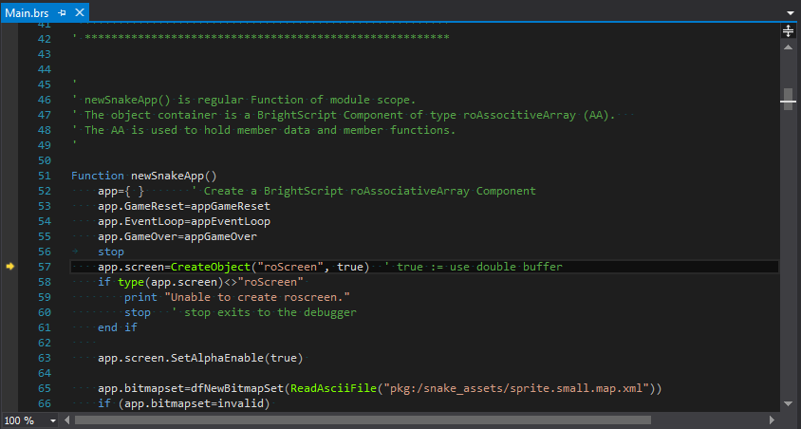

Figure 31 - Editor window showing break point

The Call Stack has a list of variables that will be listed on Locals window, if any variable is an associative array it can be expanded and the child variables are shown. This causes the debugger to send print commands to the box witch returns the variable value. Figure 32 shows Locals Window width a “app” variable expanded.

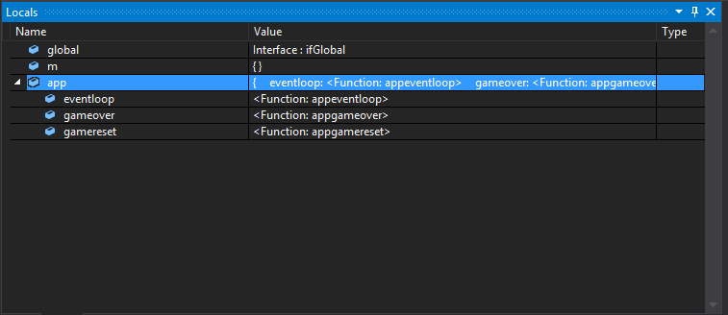

Figure 32 - Locals Window

We can use the Watch window get specific variables values, like shown on figure 33.

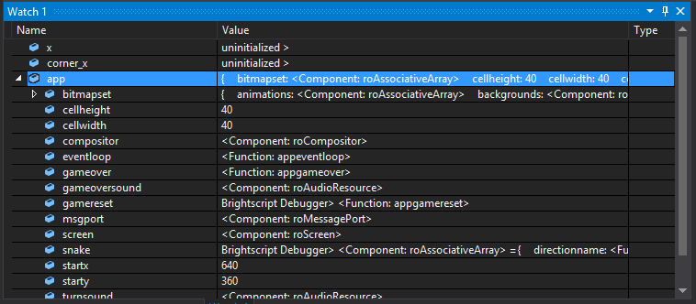

Figure 33- Watch Window

We can use Immediate Window too, like shown on figure 34.

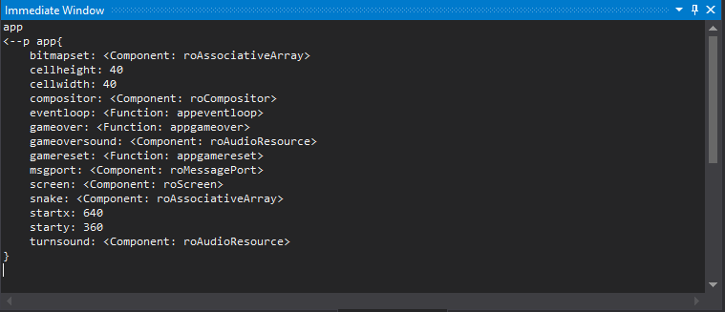

Figure 34 - Immediate Window

Using these windows, we can change variables value like shown on figure 35.

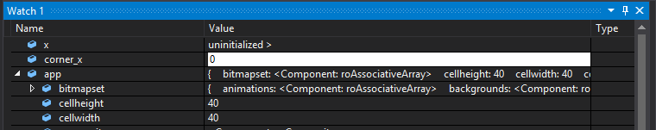

Figure 35 - Editing value using watch window

## Tool Windows

It was implemented two windows to interact with the box, the first is the remote window, and the second is the screen shot window.

The Roku Remote window uses the implementation on debugger and allows to emulate the box remote. Remote Window is shown on figure 36.

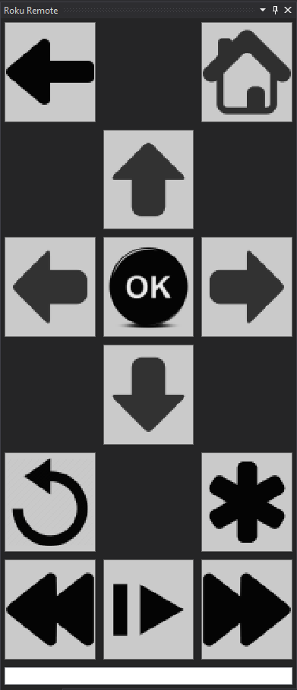

Figure 36 - Remote Window

The screenshot window uses the screen shot util from box site to take continues screenshots from the box, this allows to develop using a box without output device or remote debugging. Figure 37 shows Screenshot window.

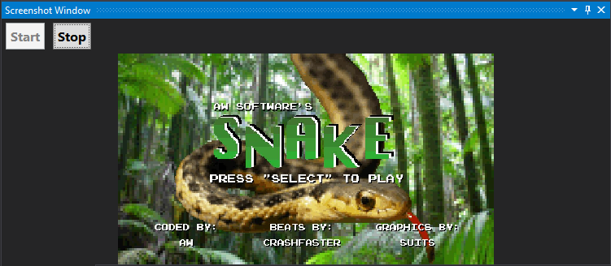

Figure 37 - Screenshot Window

# Conclusion

The Visual Studio extension supports all proposed features, namely, code editing, syntax highlighting, error validation at development time, IntelliSense, build and deploy the application, and integrated debugging.

The extension can be used to develop and debug a simple project. For more complex projects it requires improvements, identified next.

The Parser component doesn’t support all BrightScript statements. It also requires support for chained if else’s and support for the use of reserved words as method identifiers.

The Debugger Engine needs must include in its implementation stack context navigation functionalities, thereby allowing to view stack frame variable. Its implementation also needs some performance improvements.

The IntelliSense only uses as its input the current file and built in functions. Improving it in order to have a broader contribution, the compiler should generate a database with the AST’s from all files, which could then be used as the IntelliSense source.

As future work we identified the following tasks: Convert existing code base, and add support for Scene Graph framework.

To use this extension as a tool in daily work we need to convert the existing code base to a new BrightScript project. This process will be simplified if an integrated tool to import all files from a given folder is implemented.

Scene Graph [20] is the new framework for Roku development: it allows the definition of the UI using xml files and adds multi thread support. For UI definition we need to add support for Xml files, implementing a new Xml compiler and integrate it with Xml code editor. To support multi thread we need to implement thread switching commands from telnet debugger.

# References

|  |  |
| --- | --- |
| [1] | A. Aiken, "Compilers Theory," [Online]. Available: https://www.youtube.com/playlist?list=PLLH73N9cB21VSVEX1aSRlNTufaLK1dTAI. |
| [2] | A. W. Appel, Modern Compiler Implementation in Java, Cambrige University Press, 2002. |
| [3] | "BrightScript," [Online]. Available: https://sdkdocs.roku.com/display/sdkdoc/Roku+SDK+Documentation. |
| [4] | [Online]. Available: http://dinosaur.compilertools.net/#yacc. |
| [5] | [Online]. Available: http://dinosaur.compilertools.net/#lex. |
| [6] | "GPlex," [Online]. Available: http://gplex.codeplex.com/. |
| [7] | "Gppg," [Online]. Available: https://gppg.codeplex.com/. |
| [8] | [Online]. Available: https://irony.codeplex.com/. |
| [9] | [Online]. Available: https://javacc.java.net/. |
| [10] | [Online]. Available: http://www.sablecc.org/. |
| [11] | "Python Tools," [Online]. Available: https://github.com/Microsoft/PTVS. |
| [12] | "Visual Studio Extension for Lua," [Online]. Available: https://github.com/Microsoft/VSLua. |
| [13] | Microsoft, "Visual Studio MI Debug Engine," [Online]. Available: https://github.com/Microsoft/MIEngine. |
| [14] | "MEF - Managed Extensibility Framework," [Online]. Available: https://msdn.microsoft.com/en-us/library/dd460648(v=vs.110).aspx. |
| [15] | "VSPackages," Microsoft, [Online]. Available: https://msdn.microsoft.com/en-us/library/bb166424.aspx. |
| [16] | "Creating Project and Item Templates," Microsoft, [Online]. Available: https://msdn.microsoft.com/en-us/library/s365byhx(v=vs.100).aspx. |
| [17] | "How to: Create Item Templates," Microsoft, [Online]. Available: https://msdn.microsoft.com/en-us/library/tsyyf0yh.aspx. |
| [18] | "VSProjectSystem," [Online]. Available: https://github.com/Microsoft/VSProjectSystem/. |
| [19] | "MSBuild Project File Schema Reference," [Online]. Available: https://msdn.microsoft.com/en-us/library/5dy88c2e.aspx. |
| [20] | "Scene Graph," [Online]. Available: https://sdkdocs.roku.com/display/sdkdoc/Scene+Graph+XML+Tutorial. |
| [21] | "PowerShell Tools," [Online]. Available: https://github.com/adamdriscoll/poshtools. |

Figures Index

Figure 1 - Component diagram 3

Figure 2 - Phases of a compiler, and interfaces, extracted from [2] 4

Figure 3 - Combined ﬁnite automaton, extracted from [2] 7

Figure 4 - LR(0) states for Grammar, extracted from [2] 8

Figure 5 - Abstract Syntax Tree Sample, extracted from [2] 9

Figure 6 - Compiler Components 14

Figure 7 - FSA - Finite State Automata, extracted from [2] 15

Figure 8 - Shift reduce table, extracted from [2] 16

Figure 9 - Debuger diagram 17

Figure 10 - Debugger Application 18

Figure 11 - Telnet component diagram 20

Figure 12 - Compiler output windows 21

Figure 13 - Output visualizer 22

Figure 14 - UI Commands 22

Figure 15 - Deploy process 22

Figure 16 - Configurations Window 23

Figure 17 – Remote 25

Figure 18 - Visual Studio Plugin diagram 27

Figure 19 - Visual Studio project dialog 28

Figure 20 - Project created 28

Figure 21 - New item dialog 29

Figure 22 - Base code file 29

Figure 23 - Syntax highlighting 31

Figure 24 - Editor error 31

Figure 25 - Error window 32

Figure 26 – intellisense 32

Figure 27 - Debug Engine Class Diagram 33

Figure 28 - Debugging BrightScript 35

Figure 29 - Output Window 35

Figure 30 - Call Stack Window 36

Figure 31 - Editor window showing break point 37

Figure 32 - Locals Window 37

Figure 33- Watch Window 38

Figure 34 - Immediate Window 38

Figure 35 - Editing value using watch window 39

Figure 36 - Remote Window 39

Figure 37 - Screenshot Window 40